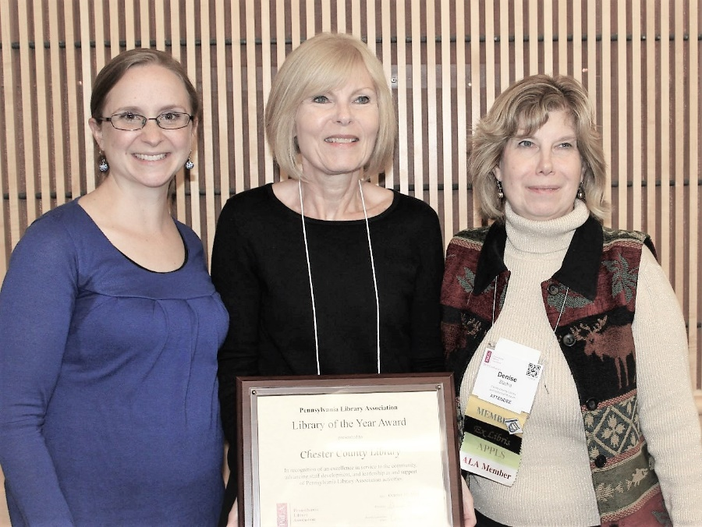
EXTON: The Pennsylvania Library Association named the Chester County Library as “Library of the Year” Tuesday during the association’s annual conference in Erie, Pennsylvania. The Chester County Library is the second in Pennsylvania to receive this statewide award. The designation comes on the heels of the library’s recent award as a PA Forward Gold Star Library.

Each year, the Pennsylvania Library Association recognizes members who have contributed significantly to the library profession and the betterment of libraries in Pennsylvania. The association’s newest award honors a library that exhibits excellence in serving its community, advancing staff development, and leadership. The Pennsylvania Library Association is pleased to present the 2019 Library of the Year Award to the Chester County Library, located in Exton, Pennsylvania.
Left to right: Carrie Sturgill, Head of Youth Services, Radnor Memorial Library, 2019 Chair of the Awards Committee; Marguerite Dube, Director, Chester County Library, Accepting the 2019 Library of the Year Award
Denise Sticha, Executive Director, Centre County Library System, 2019 PaLA President

“The Pennsylvania Library Association is able to do what we do thanks to the unwavering efforts of our volunteers and our members,” said Christi Buker, PaLA Executive Director. “This award is our way of shining a light on what all librarians, library staff and our volunteers do to continue promoting the value libraries bring to communities they serve. We are thankful for their support and engagement and are honored to be able to recognize their efforts. Congratulations to the Chester County Library!”

Serving the Community
The Chester County Library is deeply committed to serving their community. Every staff member participates in community outreach events outside of the library’s walls. This outreach is included in part of their strategic planning through increasing the community’s awareness and recognition of the library’s services and efforts. Since 2017, the Chester County Library has also participated in the Office of Commonwealth Libraries’ Turning Outward Initiative. This program has been a three year commitment of training, coaching and mentoring in Community Engagement.

Among the library’s many accomplishments is its ever-evolving and diverse partnerships with community agencies including the Financial Stability Center and the Chester County Opportunities Industrialization Center.

Advancing Staff Leadership
The Chester County Library is committed to maintaining a professional, knowledgeable, and well-trained staff. Each year a Staff Development Day is held for staff, working closely with Commonwealth Libraries to ensure they meet continuing education standards. Various in-house training programs are held to enhance staff skill levels and to keep them abreast of human resource topics. Staff members are encouraged to attend PaLA Conferences, Chapter Conferences, Support Staff Workshops, and other training made available by the Pennsylvania Library Association.

The Chester County Library is an Institutional Member of PaLA, as are the Friends of the Chester County Library. Staff members of the Chester County Library provide not only leadership within their community, but also statewide, and have served on PaLA committees, are graduates of the PALS program, and have presented at the PaLA annual conferences. The Chester County Library also provides in-kind graphic services for such landmarks as the Carolyn Field Awards, conference program books, and chapter events, and the statewide editorial calendar.

In July of 2019, the Chester County Library became a PA Forward Gold Star Library.

“On behalf of the staff of the Chester County Library, I wish to thank the Pennsylvania Library Association and the Awards Committee members for this great honor,” stated Chester County Library Director, Marguerite Dube. “I would also like to thank our Board of Trustees, our Friends groups and the County Commissioners, who encourage participation in state and local association activities, community engagement, and professional development, helping to make this award possible”

For a listing of previous award winners, visit https://www.palibraries.org/page/Awards. For more information about the work of the Pennsylvania Library Association, visit www.palibraries.org.

The mission of the Chester County and Henrietta Hankin Branch Libraries is to provide informational, educational and cultural services to the residents of Chester County so that they may be lifelong learners. The Chester County Library & District Center is located at 450 Exton Square Parkway, Exton, PA. For hours or more information, visit our website at www.chescolibraries.org

