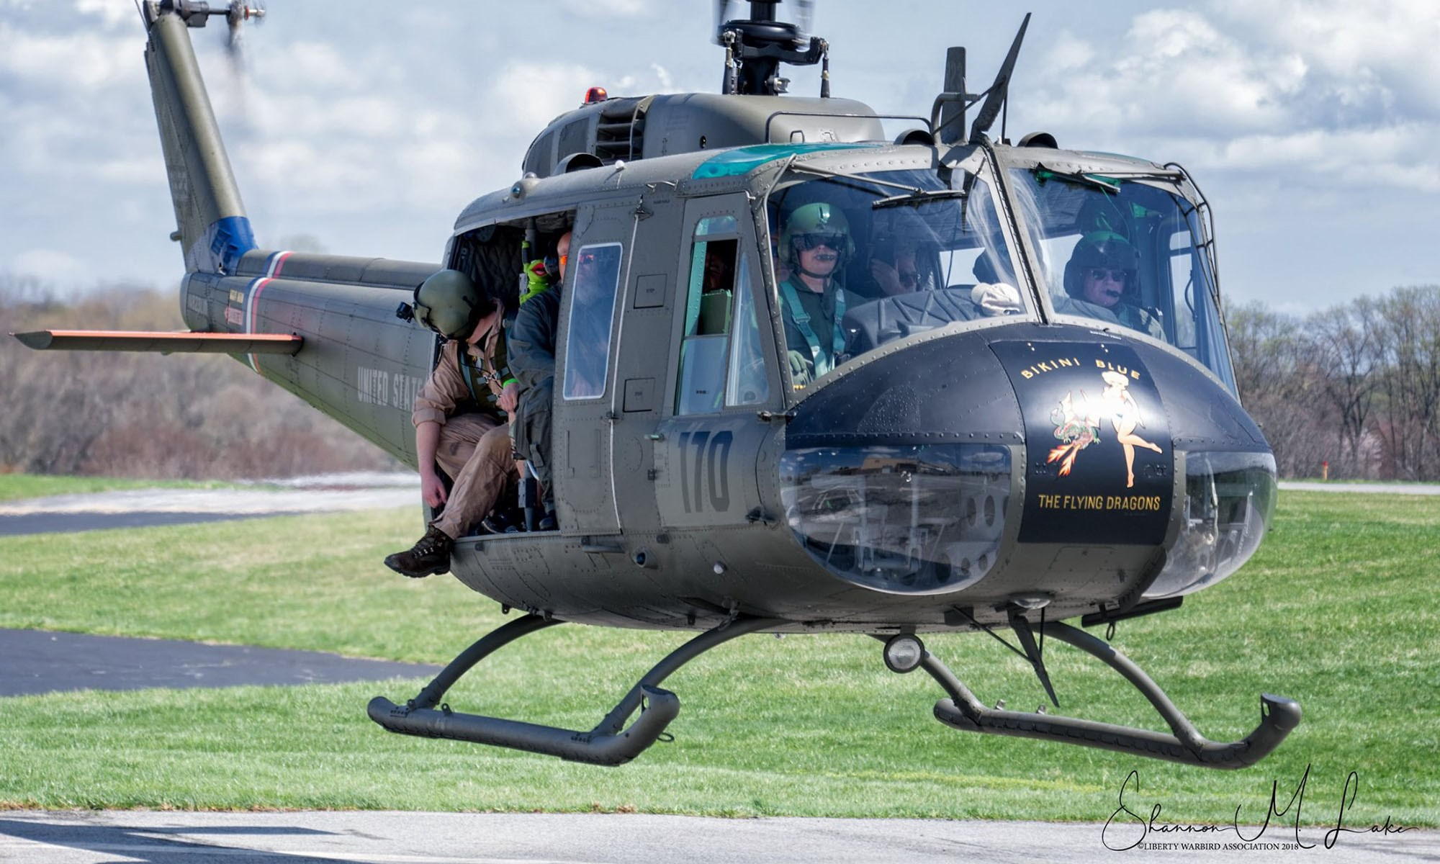
Photo courtesy of the Liberty War Birds

Visit the restored, Vietnam-era Huey 823
helicopter in Newberry Commons, Etters
Saturday, May 14 2pm-4pm

Visit the display of Vietnam-era war mem- orabilia at Red Land Community Library from 10am –1 pm. Then join us outside in the parking lot witharea groups as we wait for members of the Liberty War Birds to
land the Huey at 2pm. Learn about the role of this helicopter during the Vietnam War from 2pm-4pm.
Upcoming program:
Monday, May 23 at 6pm Charles “Buck” Buchanan Helicopter Pilot in Vietnam
Every war has an image that defines that conflict. In Vietnam, it was the “Huey” heli- copter. “Buck” Buchanan spent four years active duty as an Army helicopter pilot.
Hear his in-depth presentation at the library. Register at Yorklibraries.org/events

70 Newberry Commons Etters, PA 17319 717-938-5599

